**Health Insurance using Machine Learning**

**Project Report**

1. **INTRODUCTION**
   1. **Overview**

The Machine Learning model is built on IBM Watson Studio using Auto AI, this model works as backend, the front-end (User Interface) i.e. Web Page is built using Node-Red that too through IBM Cloud. On the Webpage, the inputs are to be provided and after submitting the details, the predicted value of insurance is displayed in real time.

1. **THEORITICAL ANALYSIS**
   1. **Block diagram**

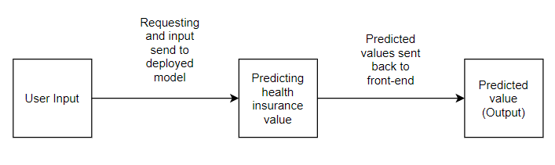

* 1. **Hardware / Software designing**
* **Hardware**

Hardware used for this model are on IBM Cloud, any desktop/PC or Laptop with good internet connection is compatible.

* **Software**

In software front, the front-end of the model is a Web form build using node red, which is integrated with back-end which is building and deployed using IBM Cloud Services.

1. **EXPERIMENTAL INVESTIGATIONS**

Multiple models were trained using Watson Auto AI and the best one with least RMSE is selected for deployment.

1. **FLOWCHART**

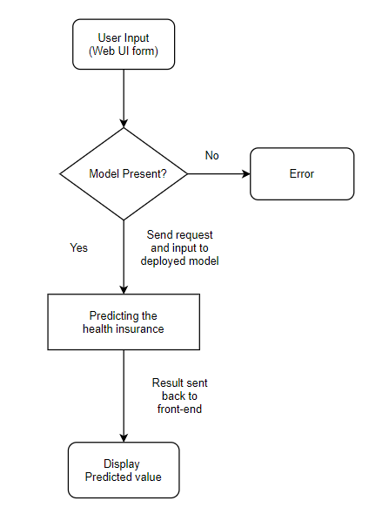

1. **RESULT**

The result which will be displayed on the web UI is the predicted value of Health Insurance.